Eight Discipline Report (8D Report)
To: | 8D report No.: CPCQ0120
From:：Chicony Power Technology | RMA claim No.: N/A
CC： N/A | Chicony P/N: A045R07DH
CC： N/A | Customer P/N:
Submit date: 2016/1/14 | Product description: 45W adapter
Receive date: 2016/1/21 | Defect D/C or Lot No.: 1507/1510  Fail sample: WDUVA0CGC9AFPS (Version 0C)  WDUVA0CNJ9K07X (Version 0C)
Subject：45W adapter samples failed in conduction test.
D1.) 問題解決成員:Use Team Approach
主持者 (Team Leader)： Henry_Zhang
內部成員 (Internal Team Members):
CQS: Xiaoyue_Wang
RD: Brandon/Frankly/Jackson
QE&IPQC: BL_Zhang
外部成員 (External Team Member):
D2.)問題說明:Problem Description:
(Note: Use who, what, when, where, why, how, how many to specify the Customer’s problem.)
Customer feedback information:
claimed that CPT 45W adapter failed in conduction test on 1/14.
HP P/N:
CPT P/N: A045R07DH
Defect S/N : (1)WDUVA0CGC9AFPS (Version 0C) (2)WDUVA0CNJ9K07X (Version 0C)

Fail sample
The test data from customer show as below:
Fail sample (WDUVA0CGC9AFPS Ver. 0C) :
The test result over 2.62dB at 162kHz.
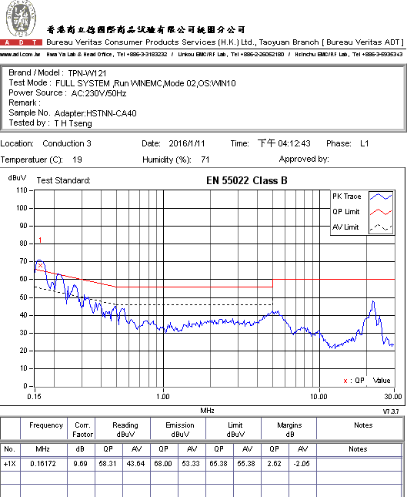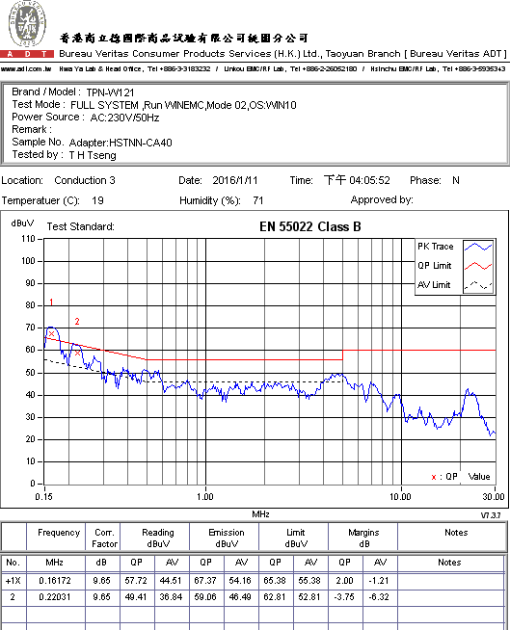

D3.)內部或客戶的暫時解決辦法及實施日期:Implement and Verify Containment Action:
(Note: Internal / external containment action effectiveness and date.)
We carry back 2pcs failed sample for analysis.
Owner: CPT Date: 2016.1.20
D4.)不良原因確認: Define and Verify Root Causes:
(Note: Identify and verify all suspect causes, which needs explain why the problem occurred.)
Analysis and findings:
We retest the failed sample (WDUVA0CGC9AFPS Ver. 0C) with dummy load in 3rd party EMI Lab. And the test margin has 0.97dB at 177kHz (QP) in fail sample. The test results are shown as below:
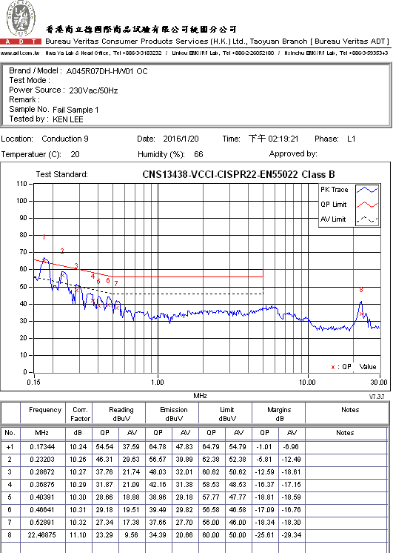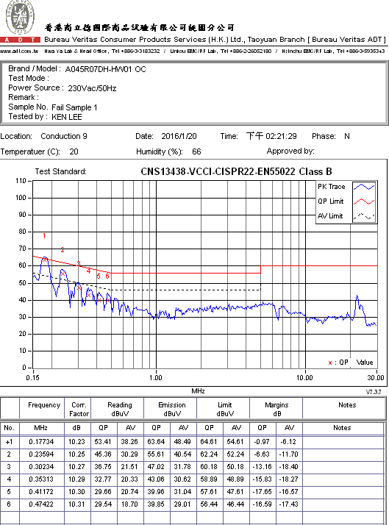
Fail sample (WDUVA0CGC9AFPS Ver. 0C)

Defect Symptom Verification:
- After retest the defective adapter, we disassemble the sample case and change another bulk capacitor CK1 (LTEC/201C0TY6682CCFHF) on hand. The test margin becomes to 5.68dB at 169 kHz.
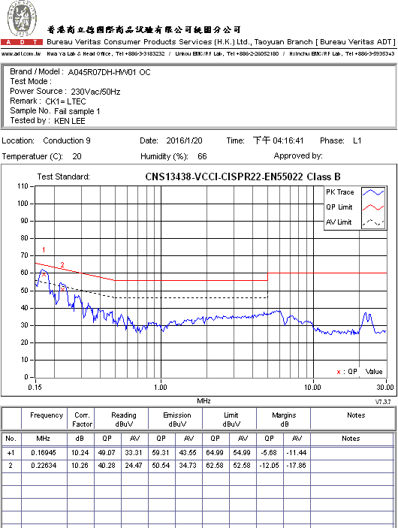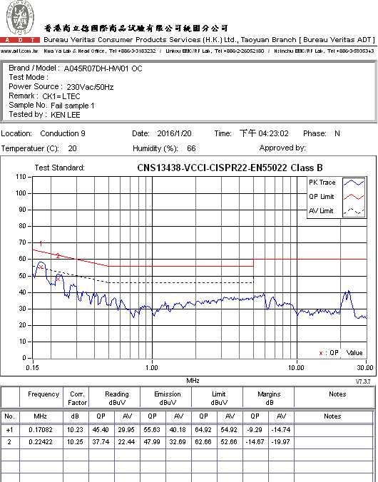

- We test equivalent series resistance (ESR) of capacitors CK1 by LCR meter (WK3260B). The ESRs of capacitor in failed sample & another sample are 1.53ohm & 1.02ohm respectively. ESR of failed sample seems higher than another one.

- We retest 10pcs LTEC capacitor samples (201C0TY6682CCFHF) on hand. The test results are shown as below. ESRs of other 10pcs LTEC capacitors are lower than the capacitor in failed sample.

 | Sample1 | Sample2 | Sample3 | Sample4 | Sample5 | Sample6 | Sample7 | Sample8 | Sample9 | Sample10
ESR(Ω) | 1.02 | 0.995 | 1.02 | 1.05 | 0.985 | 0.985 | 0.987 | 1.01 | 0.99 | 0.985

According to above experiment, we infer it should be the abnormal ESR of LTEC capacitor causes the EMI issue. The failed capacitor will be provided to vendor for analysis, and required vendor improves the capacitor characteristic.

- The vendor analysis reports of failed sample capacitor are shown as below:
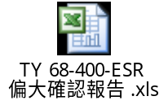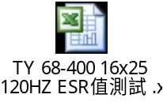
Since there isn’t defined ESR specification for LTEC capacitor (201C0TY6682CCFHF), in vendor opinion, ESR of failed sample is normal. And the ESR test data for other 50pcs capacitors from vendor production line are between 1.103ohm and 1.349ohm.

D5.)改善措施:Corrective Action Verification:
(Note: Be make sure the corrective actions is effective in process as well as able to fix the customer complaint problem)
- In order to further control EMI, ESR of capacitor CK1 will be verified by IQC in factory. evidence data for ESR measurement inspection procedure are shown as below:
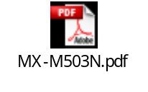
Owner: IQC Date: 2016.1.22
- Before vendor improve ESR characteristic of capacitor, LTEC capacitor will be prohibited to use in A045R07DH series adapter.
- Required vendor defines ESR specification and improves the ESR characteristic of capacitor. (follow ELITE(201C0DW6680EZFHF))
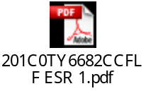
Owner: CE Date: 2016.2.15
D6.)改善措施實施日期:Implement Permanent Corrective Actions:
(Note: Be provide the phase-in date or lot# of corrective actions implementation in process)
Due date: 2016.1.22
D7.)預防再發生措施:Prevent Recurrence:
(Note: Modified the management, operating systems, practices, and procedures to prevent recurrence for the problems as well as lessons learned cases.)
The same as D5.
D8.)確認並感謝問題解決成員:Check and Congratulate the Team:
(Note: Recognize the collective efforts of the team.)
Thanks to all QIT members.

